**HOME CHALLENGE**

**Objective :**

**To make a circuit for output as**

**FIRST LED BLINKS ONCE**

**FIRST TWO LEDs BLINK TWICE**

**FIRST THREE LEDs BLINK THRICE**

**ALLFOUR LEDs BLINK FOUR TIMES**

**CIRCUIT DIAGRAM:**

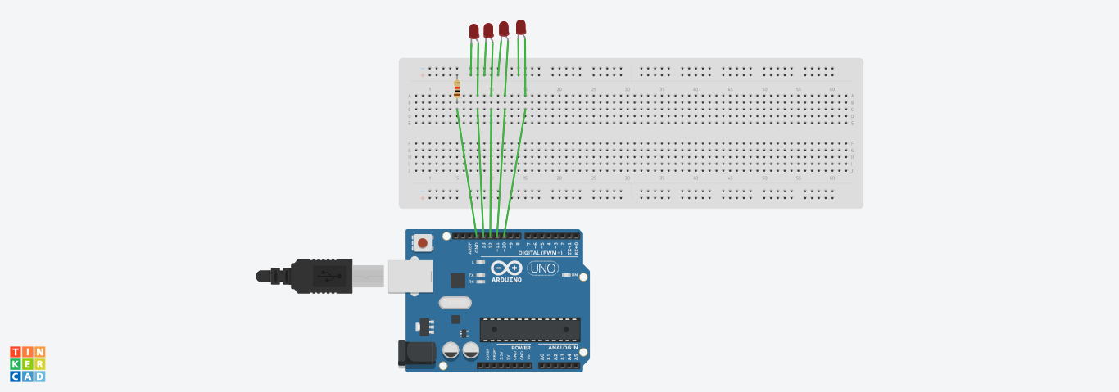

**CODE:**

void setup()

{

for(int i=0;i<4;i++)

pinMode (i, OUTPUT);

}

void loop()

{

for(int i=0;i<=3;i++)

{

for(int j=0;j<=i;j++)

{

for(int k=0;k<=i;k++)

{

digitalWrite(k,HIGH);

}

delay(300);

for(int k=0;k<=i;k++)

{ digitalWrite(k,LOW);

}

delay(300);

}

}

}